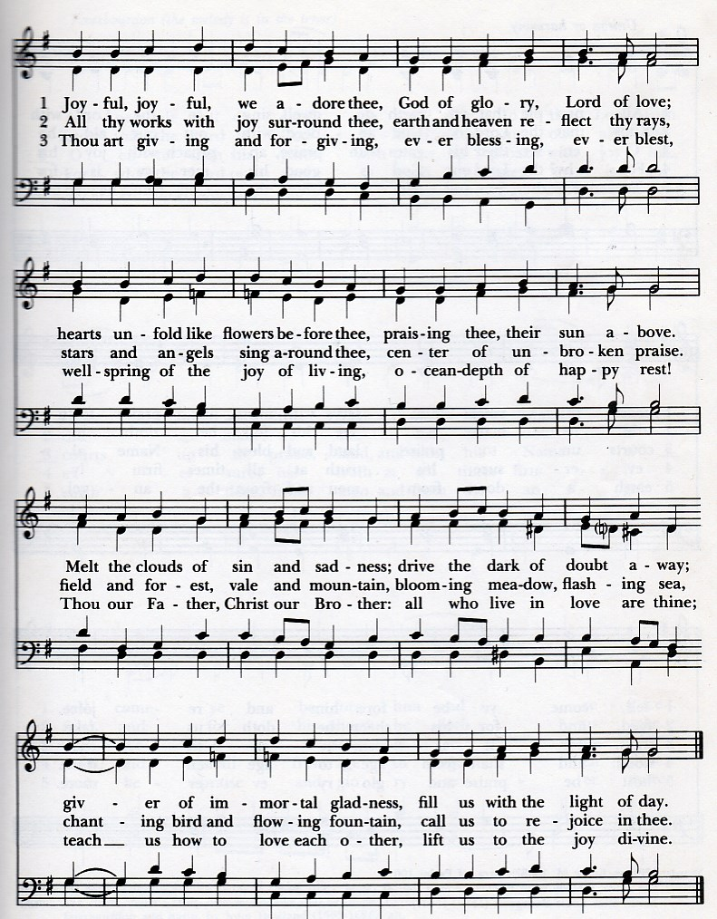

In – stru - ments You made to guide us Mo - thers who Christ’s love doth share

King of grace and peace and pa -tience These the les - sons mo - thers tell.  
For the gift of moms, we thank Thee Praise to You, we do de - clare.

Hon - or mo - thers, God com - mands us, Show re - spect and lov - ing care,

Han -nah’s pray - ers and Ma - ry’s song Tell ac – cep - tance of God’s will.  
All cre – a - ted by Ho - ly Maker Work – man - ship be - yond com - pare

Lord ,we thank you for the moth - ers by whose faith we come to Thee;

Through the a - ges, lead -ing for – ward Moms who serve to glor – I - fy.

Lord, we thank you for the moth – ers Who have brought us forth on earth.

Who re - flect Your grace and mer –cy In their fa - ces, You, we see.

Eve’s first born starts all the ra - ces, Child in pain sparks Ha - gar’s cry.

Giv - ing life that we may wor – ship Sav - ior born of Vir - gin birth.